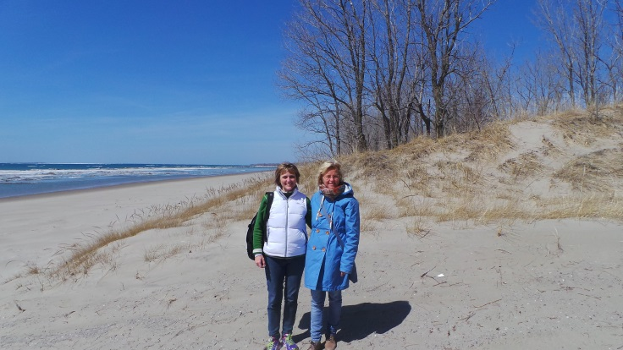
Level lll: Indigo Lounge, 2-4 of October 2015
Happy Healthy relations
“To love and be loved is to feel the sun from both sides.”
David Viscott.
Have supporting relationships.
Find people who will challenge you, believe in you and
inspire you to improve.
If you want to have a great life, enough people must say that they need you in their lives.
Be authentic…… be someone other people trust….
Would you rather be right, or would you rather be happy and effective?
The most important things in life aren´t things at all, in fact the most important things are the relationships you have with family, friends and others. Research has shown that people who just have things aren´t very satisfied, while people who have many good relationships usually have a happy, successful life.
“A smile is the shortest distance between two people.” Victor Borge
Knowing your archetypes and balancing your archetypical energies will free your energy both in your private and personal life. We will identify your own basic archetypes in survival strategies
“The Child – the Victim – the Prostitute and the Saboteur. Being aware of the shadow sides – and how to deal with it. Balancing the archetypal energies and bring them into difficult and challenging situations in your life.
Benefits: To set healthy boundaries, to be playful and also to be responsible. To have a strong self-esteem to use your power. Choose to let your light shine instead of holding back your energy. To be faithful to yourself.
We will work with how we project subconscious material on our relations, and how to take back our own power and grow in the relation instead of creating conflicts.
Emotions are essential for our survival. We will learn how to communicate with our emotions and how to express our emotions in a healthy way.
When we explore this material on level lll, we will adapt it in your coaching sessions with clients.

Trainers: Inge Grethe Henriksen & Marianne Rose Dupont from Denmark
Investment; 790 Cad, deposit before 1st of September 2015 to Indigo Lounge; 250 Cad

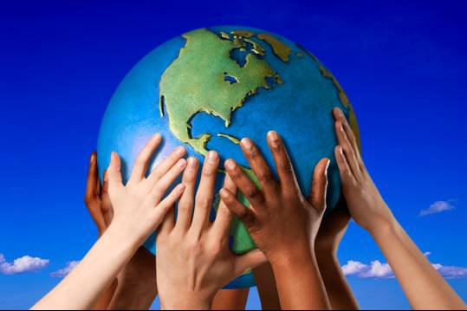
Level lV: Indigo Lounge 6-7 of October 2015
The Hero and Heroine´s Journey
On level lV we will work on how to awaken
our creativity, and to balance our ideas and
vision with our core values and a realistic plan.
So we manage to make our dreams come true.
Using generative, creative and deep trans-
formational methods we will build a platform
from where you can awaken and free your potential into your own life and into the world.
It is fundamentally important in life that we know how to balance our energy so our ego (doing) and our authentic self (being) are supporting each other. When in balance we get
more joy, love intuition and peace in ourselves and the world around us. This brings optimal performance and passion to our life and work. The unique energy of the soul will manifest even stronger.
If we identify too much in the energy of the ego we get symptoms like stress, depression, anxiety, lack of self confidence and psychosomatic symptoms.
Together we will strengthen your identity as a WholeLifeCoach. To discover your way of adapting WholeLifeCoaching in your profession.
From the myth of Hero and Heroines Journey we will work with your personal and professional story/path.
The importance through storytelling and essential archetypes to tell the stories that support your journey.
When we explore this material on level lV, we will adapt it in your coaching sessions with clients.
Trainers: Inge Grethe Henriksen & Marianne Rose Dupont from Denmark
Investment; 790 Cad, deposit before 1st of September 2015 to Indigo Lounge; 250 Cad

